Lab – 3

**Aim: "Interfacing to Distributed File System – HDFS commands and Web GUI file system browser usage"**

Rahil Acharya

CE004 20CEUOD004

1. Create /Delete a directory/file named 'Test' from HDFS web UI in '/user/hadoop'. It should give error message. Read this message and solve the error.

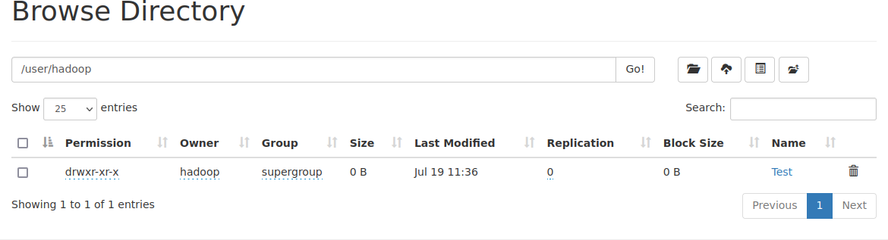

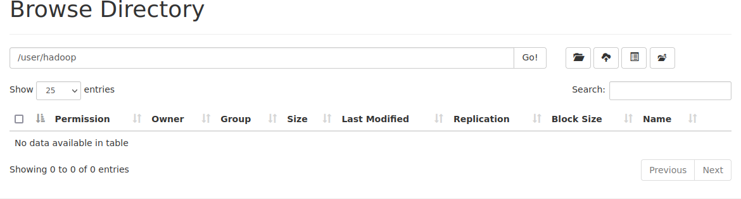

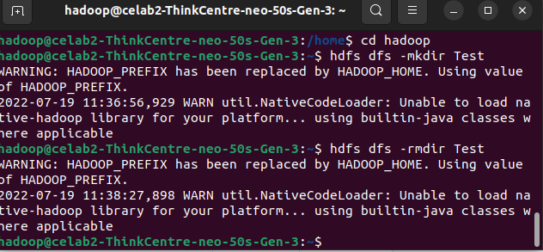

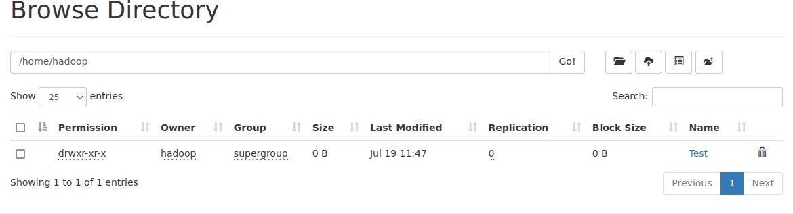

1. Create a text file in local file system and put the same file in HDFS using appropriate command.

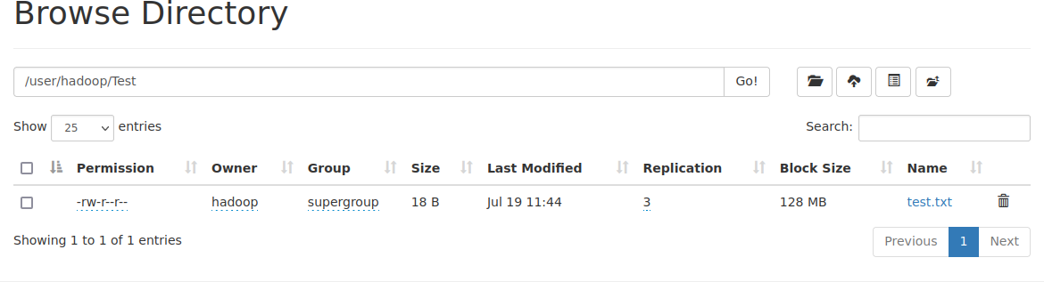

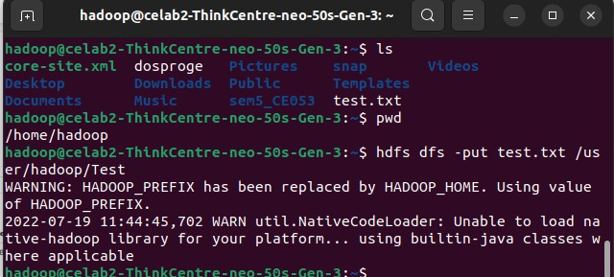

1. Display the contents of this file of HDFS on terminal.

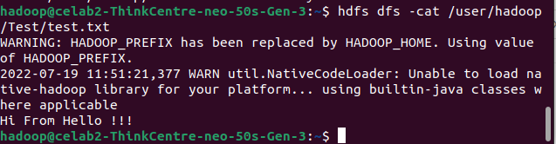

1. Download this file of HDFS on local machine and change its contents. Upload this modified file again on HDFS and verify its contents. Also make sure that this file should be deleted from local machine automatically.

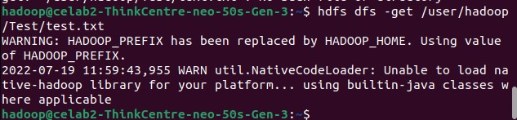

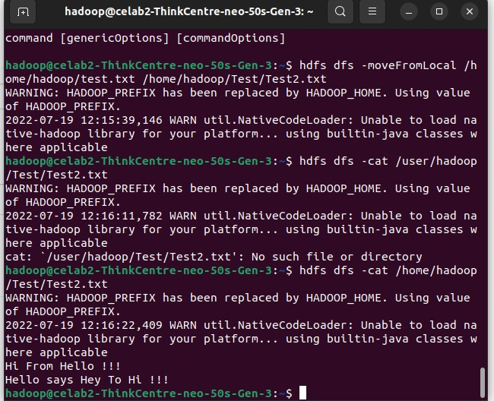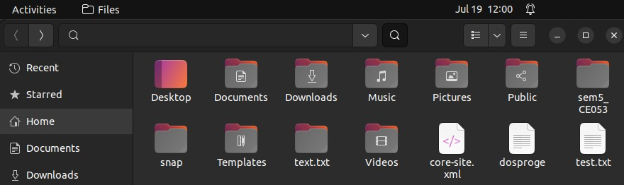

1. Fnd out ai CLI way to display all file system commands supported by hdfs. Record the list.







